Sra. Anderson
Spanish IV
La República Dominicana

https://www.bbc.com/news/world-latin-america-56227999

Dominican Republic announces plans for Haiti border fence
Published 28 February 2021
Share
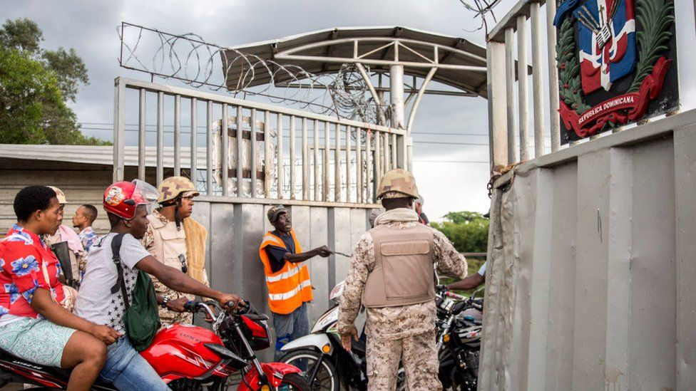IMAGE SOURCE, GETTY IMAGES
Image caption,

The Dominican Republic tightly controls the border with its impoverished neighbor, Haiti
The president of the Dominican Republic has announced plans to build a fence along its border with Haiti, which extends for about 380km (236 miles).
Luis Abinader said the barrier would help curb illegal immigration, drugs, and the flow of stolen vehicles between the two countries, which share the Caribbean Island of Hispaniola.
Mr. Abinader said work on the barrier would start later this year.
Haiti is one of the poorest nations in the Western Hemisphere.
Relations between the two neighbors have been historically difficult.
"In a period of two years, we want to put an end to the serious problems of illegal immigration, drug trafficking and the movement of stolen vehicles," Mr. Abinader said in an address to Congress.
The cost of the project has not been disclosed.
- The massacre that marked Haiti-Dominican ties
Mr. Abinader said the barrier in some "conflictive" sections would include a double fence along with motion sensors, infrared systems, and facial recognition cameras.
The Dominican Republic, which has a population of about 11 million, has already constructed some stretches of fencing along the border.
It is estimated that about 500,000 Haitian migrants are living in the country - many of them there illegally. In January, the government agreed to help Haiti provide identity papers to its citizens living in Dominican territory.

https://dominicantoday.com/dr/local/2022/02/19/the-country-begins-tomorrow-to-build-wall-against-haiti/

LOCAL February 19, 2022, | 8:13 am

The country begins tomorrow to build wall against Haiti
Shares
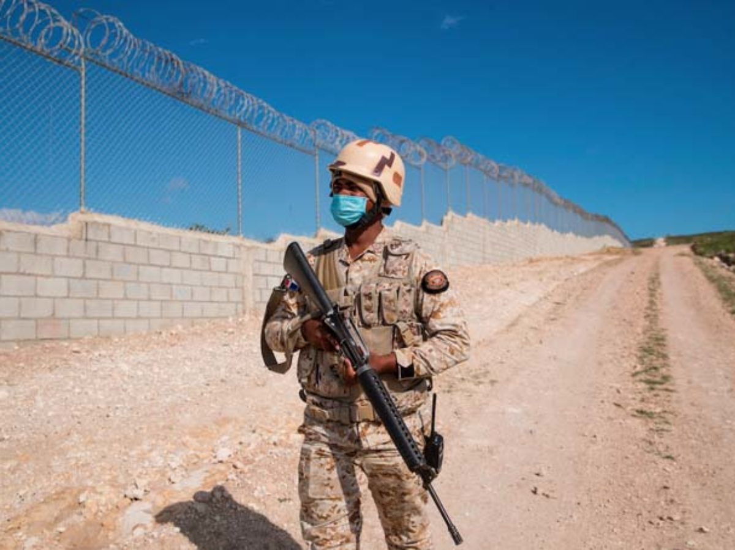
The wall seeks to control illegal and illicit migration.
Santo Domingo, DR
President Luis Abinader’s schedule for this weekend includes going to the province of Dajabón to begin work on the construction of a new border fence to have more control over Haitian migration.
The official act will take place at noon on Sunday in Dajabon province, where the president will give the first kick-off.
It is estimated that the head of state will be in the border province at approximately 1:30 in the afternoon of this Sunday. With this activity, he will finish his weekend schedule.
The construction of a 380-kilometer-long fence along the border with Haiti was announced by Abinader on 27 February last year during his accountability speech before the National Assembly.
As of May 2021, 23 kilometers of the dividing fence had been built along the border with Haiti, intended to curb the smuggling and illegal migration of Haitians.
The sections built are located at the Jimaní and Elías Piña border crossings, the second and third most important between the two countries, and the works are still in progress, as explained by General Guerrero Clase, director of Plans and Operations of the General Staff of the Ministry of Defense.
In his speech before the National Assembly, Abinader detailed that the fence will be double in the most critical places of the border and will have technological devices to prevent the passage of migrants and the commission of illegal acts.
The authorities have not disclosed the name of the company which has been awarded the bid for the construction of the fence, in a process in which three companies from the United States, Spain, and Israel participated, according to the Minister of Defense, Carlos Luciano Díaz Morfa, last September.

