Sra. Anderson

Spanish Future Tense
The Spanish Future Tense is a grammatical tense used to describe actions that will take place in the future without the need to specify the time in which they will happen. The Future Tense is the easiest to conjugate in Spanish. Why, you might ask, have I waited until now to introduce it to you? Because you really don’t need it. You can communicate 90% of what you want to say with the tenses that you already have.
What do I mean? There are three ways in which you can use the present tense to express future actions.
. 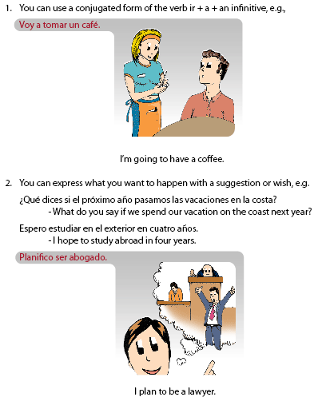

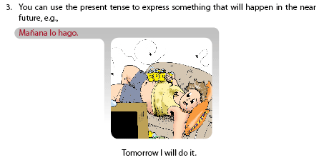
Voy a tomar un café.
I’m going to have a coffee.
Planifico ser abogado.
I plan to be a lawyer.
Mañana lo hago.
Tomorrow I will do it.
Comemos en un minuto.
We’ll eat in a minute.
You should now be quite comfortable with the first way of expressing the future, but you may not have realized that you could express the future in the third way. When you say something like, “Te llamo en una hora,” you are expressing the certainty of the future action. It’s almost as if you’ve already called that person—that’s how certain you are it will happen. The action must occur soon: not in a few days, not in a week, but today or tomorrow.
Usually, you will use the future tense when you want to express what will happen. You may want to say what will happen if someone doesn’t do what they’re told, how long you will be somewhere, or when you’ll come back from your trip.
The future tense expresses more certainty than the first and second methods above. For example, compare the following sentences:
I am going to go to Mexico next summer.
I plan to go to Mexico next summer.
I will go to Mexico next summer.
The third sentence (in the future tense) expresses the highest degree of certainty that the action will occur. To put a verb into the future tense, ALL you have to do is take the infinitive form of the verb and tack on one of the following verb endings!
-é -ás -á -emos -éis -án
Let’s take a look. | -AR verbs  CAMINAR  to walk | -ER verbs  CORRER  to run | -IR verbs  SUBIR  to go up, ascend
Yo (1st) | caminaré | correré | subiré
Tú (2nd) | caminarás | correrás | subirás
Ud., él, ella, (3rd) | caminará | correrá | subirá
nosotros/as (4th) | caminaremos | correremos | subiremos
vosotros/as | caminaréis | correréis | subiréis
Uds., ellos, ellas (5th & 6th) | caminarán | correrán | subirán
The future tense isn’t completely regular, but its irregular verbs are few. For now, look at some examples of the future tense in action.

Por ejemplo:
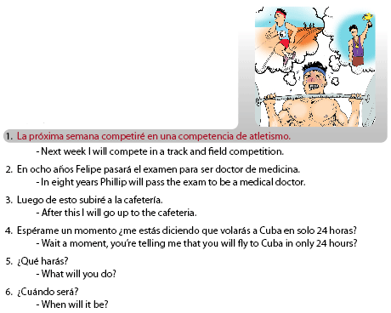
La próxima semana competiré en una competencia de atletismo.
Next week I will compete in a track and field competition.
En ocho años Felipe pasará el examen para ser doctor de medicina.
In eight years Phillip will pass the exam to be a medical doctor.
Luego de esto subiré a la cafetería.
After this I will go up to the cafeteria.
¿Qué harás?
What will you do?
¿Cuándo será?
When will it be?

