Sra. Anderson

Spanish Irregular Future Tense
The Irregular Future Tense in Spanish indicates an action that has not been done yet; or put in other words, an action that will take place after the moment in which they are being spoken. It can also express probability or uncertainty. It is also known as the Simple Future.
Now, when using this Irregular Future with Irregular verbs, this can be a bit confusing. The irregularities in the future tense are a bit difficult to predict. You will be happy to know that ser and estar, which are irregular in almost every other tense, are completely regular in the future. It’s the following that you have to look out for:
 | Irregular –ER verbs |  | Irregular –IR verbs
 | SABER  to know | PONER  to put | VENIR  to come | SALIR  to leave, go out
yo | sabré | pondré | vendré | saldré
tú | sabrás | pondrás | vendrás | saldrás
Ud., él, ella, | sabrá | pondrá | vendrá | saldrá
nosotros/as | sabremos | pondremos | vendremos | saldremos
vosotros/as | sabréis | pondréis | vendréis | saldréis
Uds., ellos, ellas | sabrán | pondrán | vendrán | saldrán

How to pronounce the Spanish Irregular Future Tense
Saldremos muy temprano, con toda probabilidad.
We’ll leave very early, in all likelihood.
No te preocupes. Vendré pronto.
Don't worry. I'll come back soon.
Ahora mismo lo sabrás.
Now you will know.
You will notice that the irregular –er verbs drop the –e from the infinitive ending, while the irregular –ir verbs replace the –i with an –r.
Other common verbs that follow this irregularity are:
poder: podré, podrás, podrá, podremos, podréis, podrán
querer: querré, querrás, querrá, querremos, querréis, querrán
tener: tendré, tendrás, tendrá, tendremos, tendréis, tendrán
valer: valdré, valdrás, valdrá, valdremos, valdréis, valdrán
There are two verbs that have an even stranger stem change in the future tense. You will simply have to memorize these.
 | HACER  to make, to do | DECIR  to say, to tell
yo | haré | diré
tú | harás | dirás
Ud., él, ella, | hará | dirá
nosotros/as | haremos | diremos
vosotros/as | haréis | diréis
Uds., ellos, ellas | harán | dirán
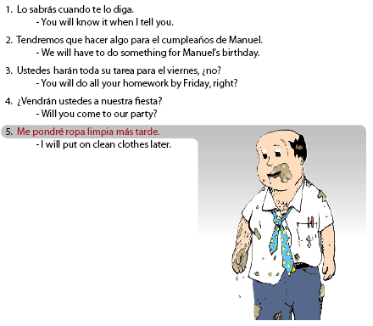
Los sabrás cuando te lo diga.
You will know it when I tell you.
Tendremos que hacer algo para el cumpleaños de Manuel.
We will have to do something for Manuel's birthday.
Ustedes harán toda su tarea para el viernes, ¿no?
You will do all your homework by Friday, right?
¿Vendrán ustedes a nuestra fiesta?
Will you come to our party?
Me pondré ropa limpia más tarde.
I will put on clean clothes later.

